Ubaid Ur Rehman

BSCS-5B

Reg. number: 00000123495

uurehman.bscs15seecs@seecs.edu.pk

Advanced Programming

Lab 6 Document (Persistent e-Cafe)

# Introduction

# A new restaurant in Islamabad wants to establish a niche by providing an online reservation system for their customers. The administration wants to use the same system to ensure optimal resource (servers, tables, time) allocation for any impromptu guests. The restaurant plans to stay open between 11:00am – 10:00pm. The customer can select any number of items and will be able to see a bill generated for all the selected items. Every delivery must happen with-in 30 minutes between the cafe opening time and 10:30pm.

# Approach

First a user is shown a menu of items available in the café retrieved from the database. And he can select as many items as he can. The selections are being stored in a list and then total bill cost is calculated by retrieving the prices of items from database, order table is updated with a new order. After the user is done with order, a timeEstimate function is being called which provides the time when the order will be ready.

# Output:

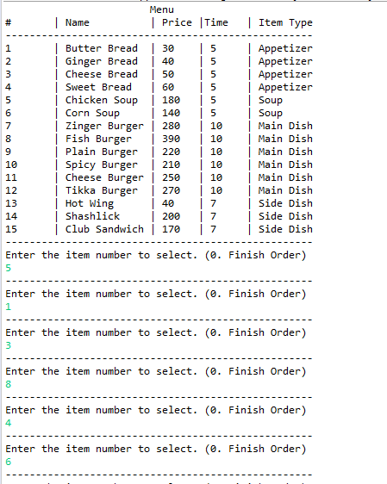

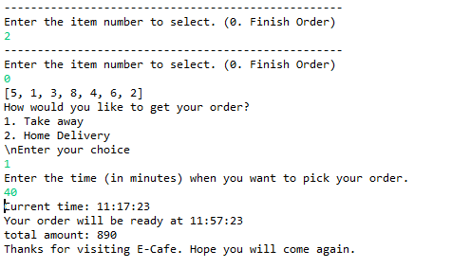

Unit Test:

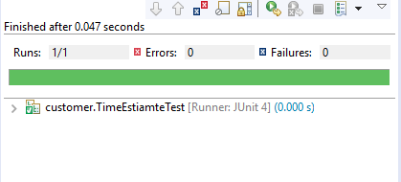

Github link: https://github.com/uurehman/e-Cafe/e-cafe-persistent